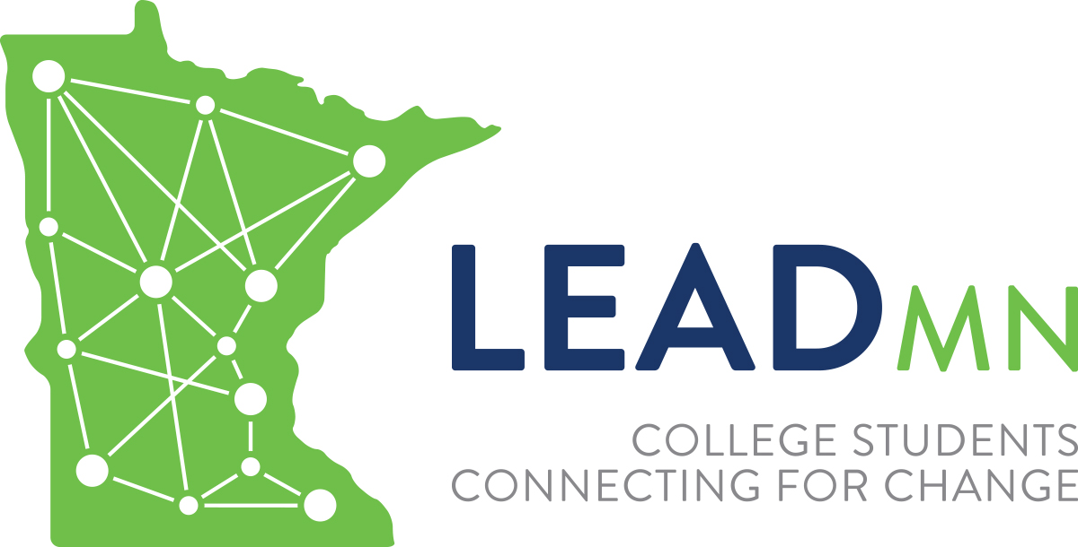
LeadMN Announces
Mark M. Welter “The 100% American” Scholarship - Round V
For 2018 Spring Semester
5 - $500 Scholarship Awards
Activity Packet
January 29, 2018

LeadMN is seeking applications for “The 100% American” Scholarship from Minnesota State college and university students. This program is sponsored through the generosity of Mark M. Welter, Ph.D. Five (5) $500 scholarships (maximum of one (1) per institution) will be awarded for the 2018 Spring Semester. Please note that "past recipients" are ineligible for this scholarship. PSEO students are eligible. "Past applicants" who were not selected to receive this scholarship previously are eligible. The student applicant must be in good academic standing.

The five (5) winners will be selected for their skills in integrating the 24 retrieval answers (pp. 2-3) with the four (4) essay questions on page 5. Accurate use of the “optional enrichment exercise” outlined on page 4 will elevate chances of winning an award. (Instructions for implementing both the standard and the extra credit choices are given under “Suggestions for integrating…,” p. 4.)

Interested instructors and staff may use it with their classes, clubs, and discussion groups.

In short, “The 100% American” may be used in two ways:

1. For personal use (not interested in applying for an award). Read the activity on page 2, complete the 24 retrieval blanks and use at your discretion.

2. To be considered for one of the five (5) awards, the applicant must read the 100% American article and complete and submit the responses for the:
- 24 retrieval questions,
- Four (4) essay questions on page 5,
- Essay questions 5-7 are optional---extra credit points will be given for answering them.

To submit your application for one of the five (5) $500 awards, email the completed 24 questions and four (4) essay questions, plus the optional essay questions, to LeadMN at ed@leadmn.org by Friday, March 30, 2018.

1515 Robert St. S., West St. Paul, MN 55118  651-297-5877 (office)  651-215-1862 (fax)  info@leadmn.org www.leadmn.org

“The 100% American”

Our solid American citizen awakens in a bed built on a pattern that originated in the Middle East and modified in Northern Europe before it was transmitted to America. He throws back covers made from cotton, domesticated in India, or linen from the Middle East, or silk, from in China. All of these materials have been prepared by spinning or weaving, processes invented in the Middle East. Our citizen slips into his moccasins, first used by the Amerindians of modern New England. He goes to the bathroom, where the fixtures are a mixture of European and American inventions created in the last century. He removes his pajamas, a garment invented in India and washes with soap first used by the ancient Gauls (modern France). He proceeds to shave, a masochistic rite first used in the second millennium BCE in Egypt or Sumer.

Returning to the bedroom, he turns on the radio and listens to some jazz which traces its roots to western Africa rhythms brought to America by slaves. He removes some clothing from a chair of the southern European style and begins to dress. He puts on garments whose form is traced to the Asiatic Steppes (mostly modern Russia), ties his shoes made from skins tanned by a method invented in ancient Egypt and cut to a pattern borrowed from pre-Christian civilizations of the Mediterranean, and ties around his neck a strip of bright-colored cloth which survived from the shoulder shawls worn by the 17th century Croatians (Balkans). Before going out for breakfast, he glances through a window, made of glass invented in Egypt; and if it is raining, he puts on overshoes made of rubber discovered and used by Central American natives long before Columbus arrived. On the way out, he reaches for an umbrella, invented in southeastern Asia, and dons a hat made of felt, a material originating in the Asiatic Steppes.

On his way to breakfast, he stops to buy a paper, paying for it with coins, an ancient Lydia (modern Turkey) innovation. At the restaurant, a whole new series of borrowed items confronts him. His plate is made from porcelain in a form first used in China. His knife is of steel, an alloy first forged in southern India; his fork originated in the Middle East and was brought to Europe by the 11th century Crusaders. His spoon is a derivative of the Roman original.

When our friend has finished eating, he settles back to renew a bad habit, smoking. He lights up a cigarette made of a plant first domesticated by pre-Columbian Americans. He reads the news printed in characters perfected by Phoenicians (c.900 B.C.) on paper invented by the Chinese (105 A.D.). At the end of an entire day or using borrowed products, he falls to his knees and thanks a Hebrew deity in an Indo-European language that he is a “100% American.”

Ralph Hinton, The American Mercury, 1937; revised by Mark Welter, Ph.D., 2000.

“The 100% American” worksheet

INSTRUCTIONS: Read “The 100% American” (page 2) and identify the items below per the article and fill in the blanks:

- Bed
- Cotton
- Silk
- Slippers (moccasins)
- Pajamas
- Soap
- Shaving
- Jazz
- Chair
- Necktie
- Glass
- Overshoes
- Umbrella
- Coins
- Plate
- Steel
- Fork
- Spoon
- Tobacco
- Alphabet
- Paper
- God
- English language
- 100% American

Instructions for the
Mark M. Welter “The 100% American” Scholarship - Round V
2018 Spring Semester

Overall purpose
To improve global perspectives and enhance competent global citizenship.

Overview and Rationale
The “100% American” scholarship confirms that all people – “all creeds, all colors, all cultures, and all countries -- have been “depositors and withdrawers at the world bank of knowledge.” In other words, what we have today is the product of all times, all places and all peoples. The corollary is palpable: there can be no superior race, color, culture, or creed. Knowing that human exchanges and borrowings are mutually universal, ecumenical, and timeless will assist students in developing an enriched understanding and tolerance for all citizens of the human community. Stated succinctly, “We must understand our commonalities in order to accept our differences.” To Martin Luther King, this was existential: “Unless we learn to live together as brothers and sisters, we will die together as fools.”

Illustrations of integrating the 24 worksheet questions (p.3) with your essay answers (p.5).
Hypothetical student answers using “The 100% American” data:
“I didn’t know that what we call “china” was actually given to us by China. Over centuries of trade, travel, and war, it diffused to the West.” “Nor was I aware that every time I used my umbrella, I was borrowing a gift that came to us from Southeast Asia.” Finally, “I love listening to jazz, but I didn’t know it originated in West Africa and was brought to America by slaves.” (Note: these illustrations may not be re-used verbatim in your essays.)

Optional Enrichment Exercise
Read William H. McNeill’s Mythistory, chapters 1-3. The author calls for a “Global Myth” to replace traditional histories. Give 3 quotations from his first 3 chapters explaining why this is essential. (Suggestion: keep in mind his central thesis, “Innovation is not so much discovered (or revealed) as it is borrowed.” Note: Answering the Mythistory questions enhances chances of winning the $500 award, but is not mandatory.

Essay Questions for the
Mark M. Welter “The 100% American” Scholarship - Round V
2018 Spring Semester

After reading “The 100% American” and completing the accompanying worksheet (p. 3), please answer the first four (4) essay questions below.

STYLE: Introduce each essay answer by repeating the question in BOLD. Questions 5-7 need not be emboldened and are optional questions, but extra credit points will be given if they are answered.

- Using what you learned about the real origins of everyday items (worksheet, p.3), describe in 3-5 sentences the role global ethnic diversity plays in our lives. Correlate items from the reading with everyday happenings, items used, thoughts/outlooks. (See “Illustrations of Integrating…” p.4.)

- Given the realities from “The 100% American,” tell how we should view ethnic diversity in the workplace? In life? In international relations? (3-5 sentences)

- If we are indebted to all cultures, creeds, countries, and colors for what we have today, why do we still have so much hatred, violence, and even wars? (4-5 sentences)

- What were your views on global diversity before this exercise? What are they now? Are there changes? Why? Why not? (5-6 sentences)

- Optional: Do the optional enrichment activity listed on page 4 using Mythistory.

- Optional: Was this activity useful in other classes? In life? In affecting your outlooks? Values? Behavior? Explain how.

- Optional: Should LeadMN keep offering activities of this genre?

Submissions: Electronically send the completed essay in MS Word or PDF format as a file attachment to ed@leadmn.org no later than Friday, March 30, 2018, midnight. Please put “The 100% American” in the subject line of your email. INCLUDE: Your full name, student ID, institution, phone number, email and current mailing address with your submission.

If you are selected to receive a $500 award you will be asked permission to allow LeadMN to publicize your essay online and in print format. Not granting permission for publication will in no way impact your current award or opportunity to receive future awards.

The five (5) recipients will be announced on Friday, May 4, 2018.

